Pharmacy Dashboard

Introduction
This project is created using Microsoft Excel to analyze and visualize pharmacy sales and inventory data. The dashboard provides a simple and interactive way to understand sales performance, product performance, inventory levels, and other important business information.

Objective of the Project

The main objective of this project is to create a simple and interactive pharmacy dashboard using Microsoft Excel. The dashboard helps users monitor pharmacy sales, inventory levels, product performance, and overall business performance.

The project helps solve the problem of analyzing large amounts of pharmacy data manually. By presenting the information through charts, tables, and interactive filters, users can quickly understand important sales and inventory information and make better decisions.

Dataset Information

The dataset used in this project contains sample pharmacy sales and inventory data. The data was prepared and organized in Microsoft Excel for analysis and dashboard creation.

Main Columns Used
- Product Name
- Category
- Sales
- Quantity
- Date
- Stock Level
- Price
- Profit

Data Cleaning and Formatting
The dataset was checked and organized before creating the dashboard. The data was formatted properly, unnecessary values were removed, and columns were arranged in a structured format. Date, sales, quantity, stock, and profit fields were formatted appropriately for analysis.
Dashboard Features
The Pharmacy Dashboard 1.0 provides a simple and interactive view of pharmacy sales and inventory performance.

Key Features

- Sales Trend Analysis – Shows how sales change over time.
- Top-Selling Products – Identifies products with the highest sales or quantity sold.
- Inventory Status – Provides an overview of available stock levels.
- Category Analysis – Helps compare sales and performance across different product categories.
- Profit Analysis – Provides information about profit generated from product sales.
- Pivot Tables – Used to summarize and analyze the dataset.
- Charts – Used to present important information visually.
- Filters/Slicers – Used to interact with the dashboard and view specific data.

Steps to Use the Dashboard
- Open the "Pharmacy Dashboard 1.0.xlsx" file using Microsoft Excel.

- Open the dashboard worksheet to view the main dashboard.

- Use the available filters or slicers to select specific products, categories, dates, or other available fields.

- Select different filter options to analyze specific sales or inventory information.

- Review the charts, tables, and key performance indicators displayed on the dashboard.

- To update the dashboard with new data, add or update the source data in the appropriate data table.

- Refresh the Pivot Tables and Pivot Charts after updating the data to reflect the latest information.
- Save the Excel file after making the required updates.

- Technical Details

Tool Used: Microsoft Excel

Excel Version: Microsoft Excel 2019 / Microsoft 365

Project File: Pharmacy Dashboard 1.0.xlsx

Techniques Used:

  - Data Cleaning
  - Data Formatting
  - Pivot Tables
  - Pivot Charts
  - Excel Charts
  - Slicers/Filters
  - Dashboard Design
  - Sales and Inventory Analysis

Conclusion

The Pharmacy Dashboard 1.0 project provides a simple and effective way to analyze pharmacy sales and inventory data using Microsoft Excel. The dashboard converts raw data into meaningful visual information through charts, tables, Pivot Tables, and interactive filters.
This project helps users understand sales performance, product performance, inventory levels, and profit information in an easy-to-understand format. It also demonstrates the practical use of Microsoft Excel for data analysis and dashboard development.
dash board screenshot
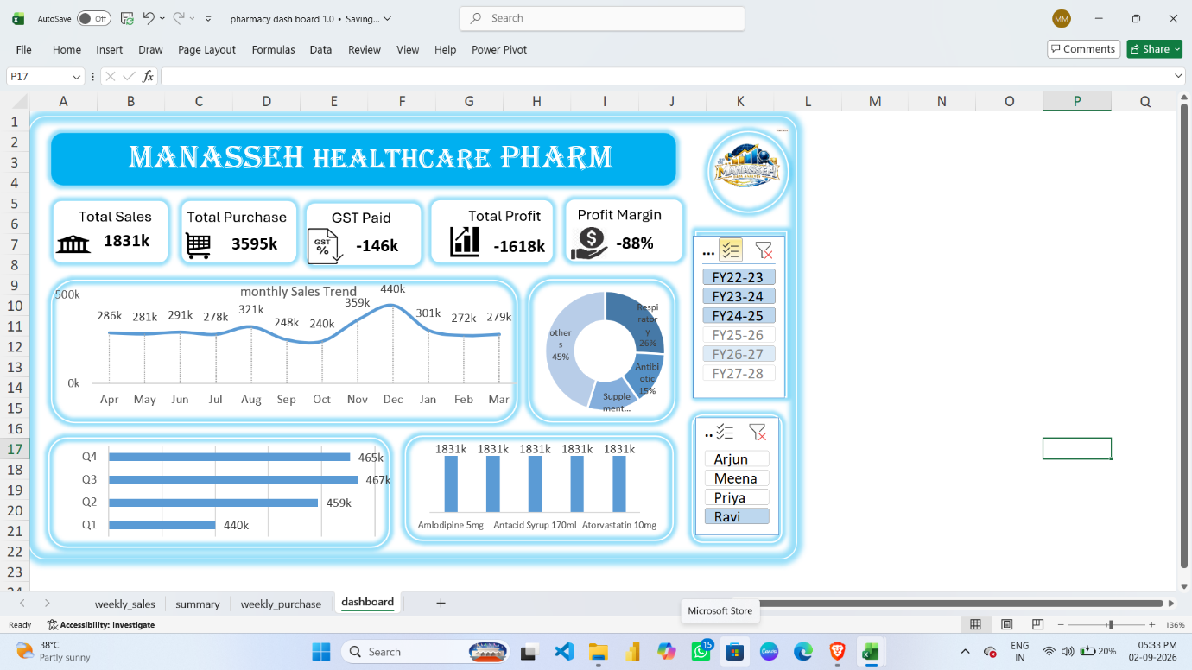
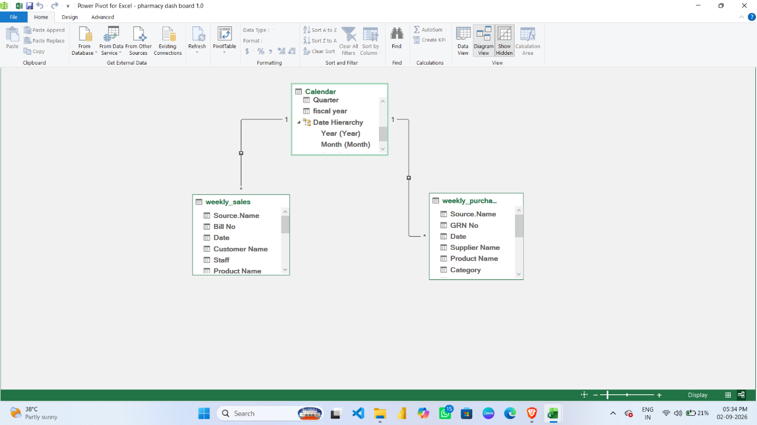
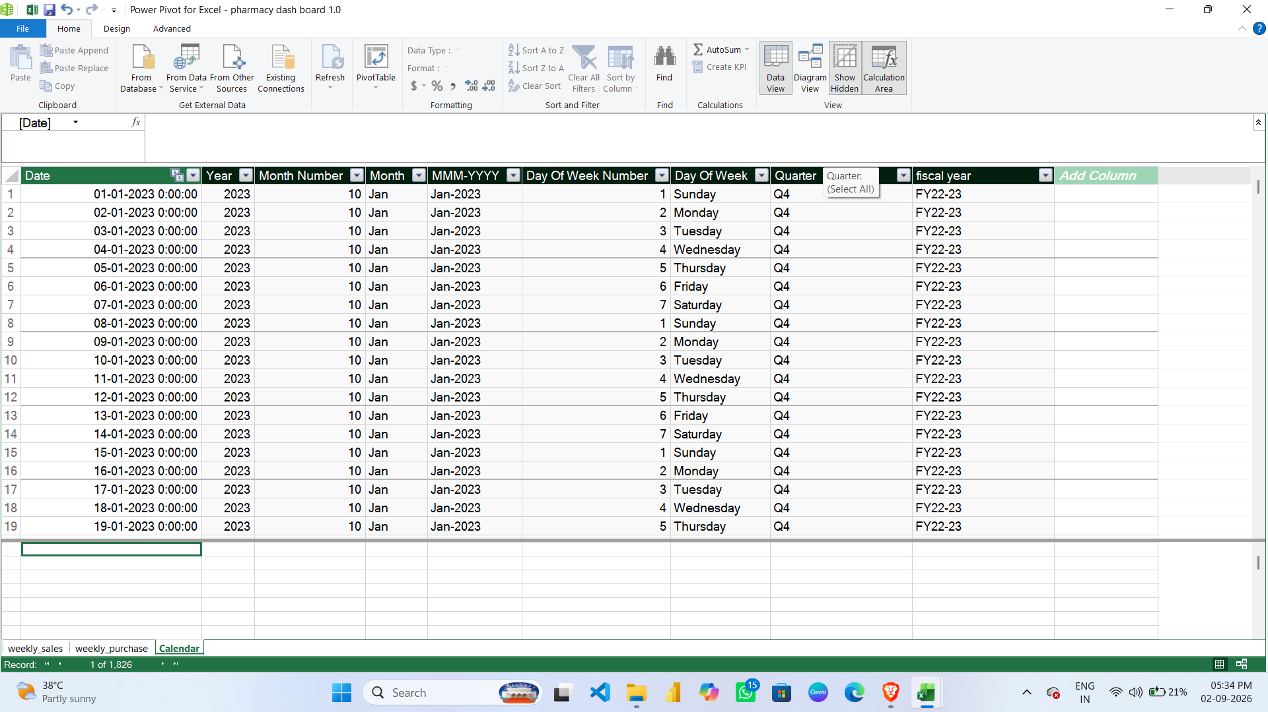

Presented by:
MANASSEH M

